FRE 501

Module 2 Assignment, Q2  
Due: 11:59 pm on November 26, 2021

Q2 and Q3 both use the USDA World Agricultural Supply Demand Estimates (WASDE) database for corn with harvested acres, yield and total use selected for the period April, 2010 to December, 2020. The WASDE data is transformed to create three variables: (1) the change in the forecasted acres from the previous report; (2) the change in the forecasted yield from the previous report; and (3) the change in the forecasted use from the previous report. The three change variables are linked to the change in the corn futures price from the previous trading day. The goal is to identify if there is statistical link between changes in the WASDE forecasts, which are contained in a particular report, and the change in the price on the day the report is released to commodity traders. We expect the futures price to increase (decrease) if the forecast for acres or yield is revised downward (upward). We also expect the futures price to increase (decrease) if the total use, which reflects the demand side of the market, is revised upward (downward).

The WASDE data is somewhat complicated because the forecasts are for end of season outcomes, which is the late fall for the case of U.S. corn. However the forecasts are reported by marketing year (September to the following August) and there is a nine month period where forecasts are being made for both the current marketing year and the next marketing year. One of the columns in the WASDE data is “ProjEstFlag”. The data associated with the “Proj.” flag (i.e., “projected”) corresponds to forecasts for the next marketing year. The first forecast is in May and the last forecast is November, 18 months later. To simplify the data cleaning, in this assignment you will work with data from the first forecast in May through to the last forecast before the transition in April.

Q2 of this assignment involves cleaning and organizing the data, and Q3 involves statistical analysis. You must choose to complete both Q2 and Q3 in either Excel or R. If you choose to work with Excel then you will download the raw data from the USDA website and begin the cleaning process from scratch. If you will work with R then you will start with a partially cleaned data set (stored as a .Rds file). For the keen R users you have the option to conduct the initial cleaning yourself. By the end of the data cleaning exercise the data is approximately the same for Excel users and for R users.

If you will complete your assignment in R then download from Canvas the zip file named “AssignQ2_3_R.zip”. Inside this zip file is a project file which must be opened first before running any of the code. The zip file also contains the data and a R Markdown template (made by Krisha), which gives you guidance for completing Q2 and Q3. Similar to Module 1 Assignment Q1 you will submit an HTML or PDF file which was rendered from your completed Markdown template.

If you will complete your assignment in Excel, then you will download the WASDE data from the USDA website, and you will download the corn futures price data from Canvas. You will answer Q2 and Q3 in the same Excel workbook, and you will answer the assignment discussion questions in a text box within the workbook. You will submit the completed workbook for grading.  
  
The detailed instructions for completing the assignment in Excel are provided below.  
  
  
**Question 2: Data Cleaning**

1. Download the zip file from <https://www.usda.gov/oce/commodity/wasde> titled “NEW: Consolidated Historical WASDE Report Data 2010- 2021” and unzip to reveal two .csv files. Open “oce-wasde-report-data-2010-04-to-2015-12.csv” in a new worksheet. Filter using Commodity = “Corn” and Attribute = c(“Area Harvested”, “Yield per Harvested Acre”, “Use, Total”) and ProjEstFlag = “Proj.”. Uncheck “481” in the WasdeNumber filter – this report has some data errors. Copy and paste to a new worksheet with name “2010-2015”. Close the original worksheet containing the full data. Save the workbook in Excel workbook format with name “MyWasdeData.xslx”
2. Open “oce-wasde-report-data-2016-01-to-2020-12.csv” and filter using Commodity = “Corn” and Attribute = c(“Area Harvested”, “Yield per Harvested Acre”, “Use, Total”). Copy and paste to a new worksheet in “MyWasdeData.xslx” with name “2016-2020”. Close the workbook containing the full data.
3. Use “Worksheet Copy” to copy sheet “2010-2015” to a new worksheet named “Combined”. While omitting the header row, copy the contents of the “2016-2020” worksheet and paste immediately below the last row in the “Combined” worksheet.
4. Use “Worksheet Copy” to copy sheet “Combined” to a new worksheet named “Pivot”. Delete all columns except “WasdeNumber”, “Attribute” and “Value”.  
     
   The goal is to convert the WASDE data from long format to wide format. There is no direct way to do this in Excel but an indirect way is to use the Pivot Table tool. Aim to create the pivot table which appears in the image below.   
     
   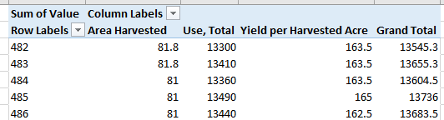
5. Copy the contents of the Pivot table (without the Grand Total column and row) to a new worksheet named “Wide”. Rename the columns as follows:  
     
   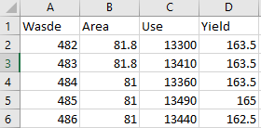
6. Sort the contents of “Wide” in increasing order of the “Wasde” column. The data should already be sorted but it is a good idea to use sort to ensure of the order.
7. Add two more column names to the right of “Wasde”. The first is “MktYear” (marketing year) and the second is “RelDate” (report release date). Use a lookup function and the “Combined” worksheet to insert the marketing year and report release date data in the new columns. Don’t worry about the duplicate values in the “WasdeNumber” column of “Combined” because for each WASDE number there is just one marketing year and one release date. The final data should look like as follows.  
     
   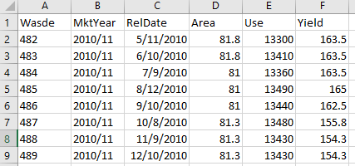
8. Download from Canvas the file “corn_price.csv”. Copy this worksheet to MyWasdeData.xlsx. Create a new column in the “corn_price” worksheet with name “P_Diff” and insert the lag price into this column (i.e., price in the cell one row higher).
9. Copy the “Wide” Worksheet and rename it to “Merged” (place at end of worksheets, to the right of “corn_price”. Delete the top row of data (i.e., Wasde 482). Rename the columns: “Area” to “Area_ch”, “Use” to “Use_ch” and “Yield” to “Yield_ch” (the “ch” refers to “change”). Referring to the “Wide” sheet, add formulas in the three renamed columns to calculate the difference between the current month value and the previous month value.
10. Add the name “P_Diff” to a new column in the “Merged” sheet. Use a lookup function with the “RelDate” column and “corn_price” sheet to add the corn price to the new column. Your results should look as follows.  
      
    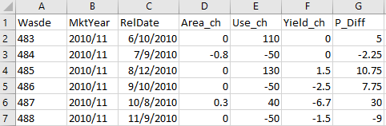
11. Copy the “Merged” worksheet to a new worksheet named “Categories”. List the following six labels in a column: “UseCutLow”, “UseCutHigh”, “YldCutLow”, “YldCutHigh”, “PCutLow”, and “PCutHigh”. Use the Median and IF function in an array formula to calculate the median value of “Use_ch” for all negative values. Name this cell “UseCutLow”. Do the same for the positive values of “Use_ch” and assign to “UseCutHigh”. Repeat these steps for the “Yld_ch” and “P_Diff” columns. The end result is as follows.  
      
    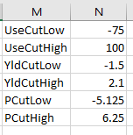 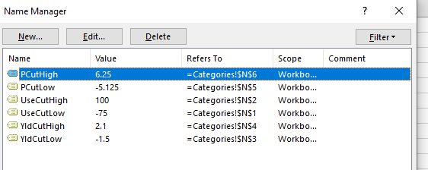
12. In the “Categories” worksheet create three new columns named “Use_Rank”, “Yld_Rank” and “P_Rank”. In the top empty cell of the “Use_Rank” column use a nested IF statement to generate the following text output.   
      
    🡪 “Use_Up_High” if the cell’s value is greater than “UseCutHigh”;  
    🡪 “Use_Up_Low” if the cell’s value is greater than zero and less than “UseCutHigh”;  
    🡪 “Use_NoChg” if the cell’s value is equal to zero;  
    🡪 “Use_Down_Low” if the cell’s value is greater than “UseCutLow” and less than zero; and  
    🡪 “Use_Down_High” if the cell’s value is less than “UseCutLow”.  
      
    Repeat this procedure for the “Yld_Rank” and “P_Rank” columns. The “Up” refers to an increase in the forecast from the month before, and “Down” refers to a decrease. The “NoChg” refers to no change in the variable from the month before. Your results should look as follows:  
      
    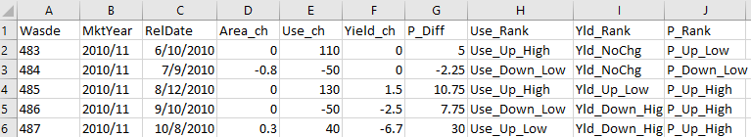  
      
    **Question 3: Statistical Analysis of the Data**
13. Copy the worksheet and name it “CrossTabs”. Delete all columns except the first three and the three ranked columns. Important: Copy the values in the three ranked values and use Paste Special Values to convert the formulas to values. Your results should look as follows.  
      
    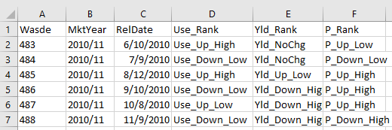

Values, not formulas

1. In the “CrossTabs” sheet use the Pivot Table tool to create cross tabulations for: (1) “Use_Rank” and “Yld_Rank”; (2) “Use_Rank” and “P_Rank”; and (3) “Yld_Rank” and “P_Rank”. Your results should look as follows.  
     
   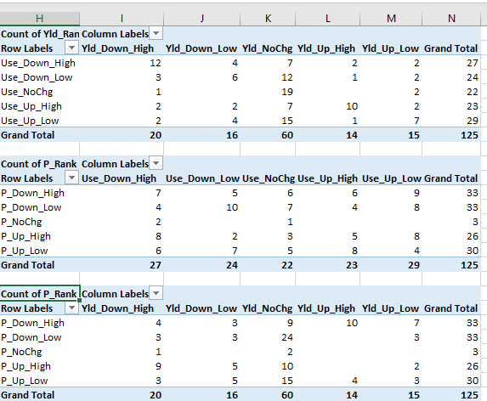
2. Create a text box in a new worksheet names “Answers” and provide answers to the following questions.
   1. How common is it to have a “win-win” scenario for long traders where forecasted yield is revised strongly downward and forecasted use is forecasted [strongly] upward. Provide a specific percentage. *Answer: 2/125 🡺 very uncommon. 4/125 is also correct because the question was not clear if the demand forecast was high only or both high and low.*
   2. Would you characterize the unconditional distribution of use and yield as given by the row and column grand totals as being reasonably well approximated by a normal distribution, or is there a noticeable skew in the distribution? 🡺 *Full marks for any answer because a judgement call is required.*
   3. The top two rows of each pivot table correspond to small and large price decreases in response to the forecast. The left (right) two columns correspond to a forecasted decrease (increase) in the WASDE variable. In the middle pivot table corresponding to use, the four values in the top left are therefore “correctly” classified according to theory, and the four values in the top right are “incorrectly” classified. The opposite is true for the bottom pivot table, which correspond to forecasted yield. How many “correct” and “incorrect” classifications are there for use and for yield? Based on a comparison of these values, is it the change in forecasted use or yield which is more strongly associated with the change in price. *Answer 🡺 In the use table, there are 26 correct classifications and 27 incorrect classifications. In the yield table, there are 20 correct classifications and 13 incorrect classifications. Based on this limited evidence it appears the association is strongest between yield changes and price changes.*
3. Your goal is to conduct a Chi Square test of association between the change in the WASDE use forecast and the change in the futures price. You will then conduct a second Chi Square test using the change in the WASDE yield forecast and the change in the futures price. Copy the “CrossTabs” sheet and name it “ChiSquare”. To conduct the test follow the steps in the video <https://www.youtube.com/watch?v=KNR59hgPC4E> .
4. Answer the following questions in the text box of your “Answers” sheet.
5. Are you able to reject the null hypothesis that the association between the change in the forecasted WASDE use and the change in the futures price is random; i.e., there is no statistical association? If yes, at what level of confidence? 🡺 *Answer = “Cannot reject”, p = 0.585.*
6. Are you able to reject the null hypothesis that the association between the change in the forecasted WASDE yield and the change in the futures price is random; i.e., there is no statistical association? If yes, at what level of confidence? 🡺 *Answer = “Can reject”, p = 0.010.*
7. Briefly discuss the disadvantage of using a Chi Square test which tests for the association between pairs of variables, versus regression which allows for a full array or explanatory variables. Hint: When working with quantitative data, think about the advantage of regression over simple correlation. 🡺 *Answer: A pair-wise regression, whether it be a correlation or a Chi Square test, fails to control for confounders. For those years, where forecasted acreage and yield are down and forecasted use is up, we should not expect to see much of a price change. However, the pair wise comparison will fail to recognize this cancelling out. This is especially problematic if the explanatory variables are correlated.*
8. To address the shortcomings discussed in your answer (f) you will regress the price change variable (P_diff) on use and yield categorical variables. Copy the “Crosstabs” sheet and name it “Regression”. Delete the pivot tables. Now create two new columns named “use_cat” and “yield_cat”. Use a nested IF statement to assign categorical values:   
     
   -2 for “Use_Down_High” and “Yld_Down_High”,   
   -1 for “Use_Down_Low” and “Yld_Down_Low”,   
   0 for “Use_NoChg” and “Yld_NoChg”,   
   1 for “Use_Up_Low” and “Yld_Up_Low” and   
   2 for “Use_Up_High” and “Yld_Up_High”.
9. Regress “P_diff” on “use_cat” and “yield_cat”. Answer the following questions in the text box of the “Answer” sheet.
10. Do the estimated coefficients have the anticipated sign, and are they statistically significant? 🡺 Answer: *Yes, the sign of the estimated coefficient on use is positive, as is expected, and the sign of the estimated coefficient on yield is negative, as is expected (see regression results below). Both estimates are statistically significant.*
11. What does the specific value of the coefficient on the “use_cat” variable represent (your answer should be stated in quantitative terms, similar to the coefficient of a dummy variable)? 🡺 Answer: *The data has been segmented into quintiles. The coefficient on use is a measure of the difference in the average price change when the forecasted use increases up by one quintile (e.g., from a “small decrease” to “no change”, or from a “small increase” to a “large increase”).*
12. What does the specific value of the regression intercept represent? 🡺 Answer: *The intercept is a measure of the average change in price when the forecast is released and forecasted use and forecasted yield both remain unchanged.*  
      
      
    